DISTRICT INFORMATION
- District Map :YadadriBhuvanagiri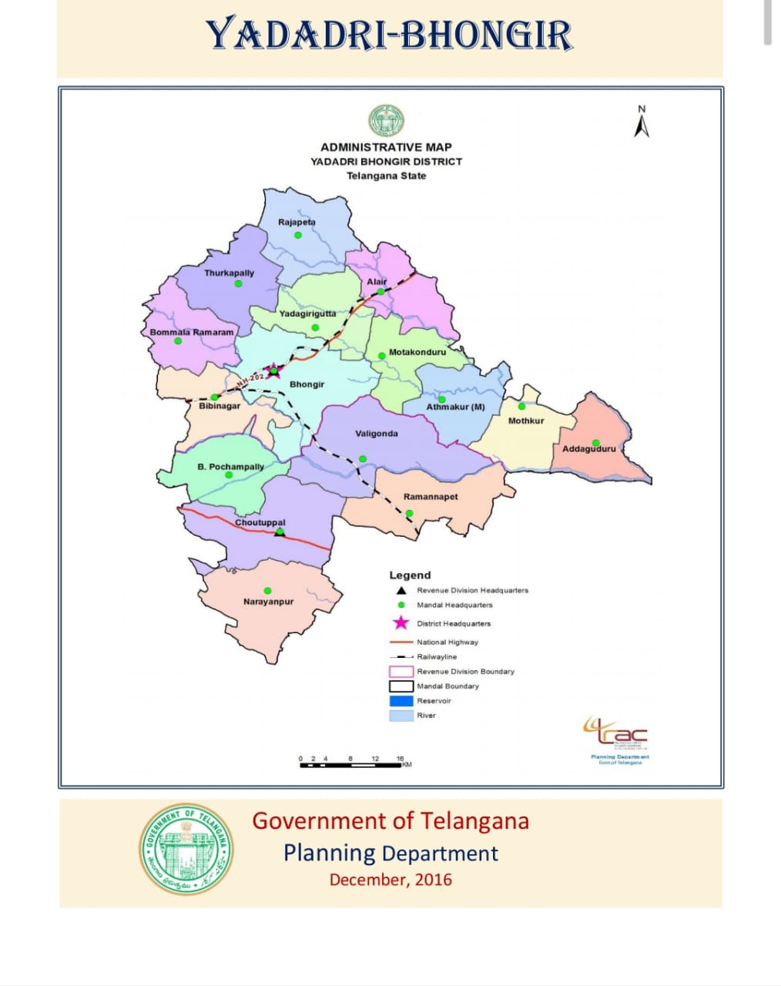

- District Administration :

i) | District Collector | Name | Address | Phone No.
 |  | SmtAnithaRamchandran | Colletorate building pagidipally 508126 | 8331997001
ii) | District Coop. Officer | Name | Address | Phone No.
 |  | Sri T.Venkat Reddy | Block-B, Room No.101-103, collectorate block,pagidipally,508126 | 9100115660
iii) | District Audit Officer | Name | Address | Phone No.
 |  | Sri G.Nageshwara Rao | Block-B, Room No.101-103, collectorate block,pagidipally,508126 | 9100115731

- Information of Societies in the District :
Sl.No. | TSCS Act, 1964 |  |  | TS MACS Act, 1995
 | Type of Society | No. of Societies | No. of Members | Type of Society | No. of Societies | No. of Members
1 | District level Coop. societies | 1 |  | Milk producers cooperative societies | 323
2 | Primary Agriculture Coop. Credit Societies | 20 | 112336 | Thrift & Credit Cooperative Societies (Mahila Societies) | 669
3 | Farmers service Coop. Credit Societies | 1 | 4253 | Thrift & Credit Cooperative Societies | 3
4 | Employees Coop. Credit Societies | 18  (under liquidation) |  | Y.B. District Women Development MAC Society | 1
5 | Consumer Coop. Societies | 03  (under liquidation) |  | House Building Cooperative Societies | 2
6 | House Building Coop. Societies | 20 |  | Labour Contract Cooperative Societies | 17
7 | Urban Coop. Banks | 2 |  | Handloom Weaver Cooperative Societies | 54
8 | Labour Contract Coop. Societies | 74 |  | Farmers Cooperative Societies | 3
9 | Joint Farming Coop. Societies | 11 |  | Tree Growers Cooperative Societies | 1
10 | Other Coop. Societies | 1 |  | Electrical & Tech. Workers Cooperative Societies | 2
11 |  |  |  | Agriculture & Marketing Cooperative Societies | 1
12 |  |  |  | Irrigation Cooperative Societies | 6
13 |  |  |  | Other societies | 6

Sd/-
District Coop. Officer
YadadriBhuvanagiri

