DISTRICT INFORMATION
- District Map : 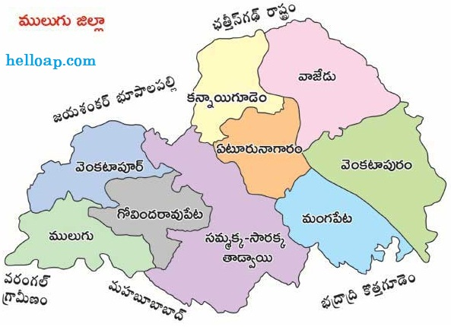

- District Administration :
1) | District Collector | Name | Address | Phone No:
 |  | S. Krishna Aditya | Collectorate complex, Mulugu | 6309522944
2) | District Coop. Officer | Name | Address | Phone No:
 |  | V.Vijaya Bhaskar Reddy | Collectorate complex, Mulugu | 9000283599
3) | District Audit Officer | Name | Address | Phone No:
 |  | V.Vijaya Bhaskar Reddy | Collectorate complex, Mulugu | 9000283599

- Information of Societies in the District:

Sl No. | TSCS Act,1964 |  |  | TS MACS Act,1995
 | Type of Societies | No. of Societies | Total Membership | Type of Societies | No. of Societies | Total Membership
1 | PACS | 12 | 54401 | Thrift Societies | 365 | 6825
2 | LCCS | 39 | 950 | Labour contract societies | 40 | 1186
3 | ICS | 2 | 247 | Seed Growver | 1 | 12
4 | CCFS | 2 | 176 | Water shed | 4 | 44
Total |  | 55 | 55774 |  | 399 | 8067

