DISTRICT INFORMATION

- District Map :
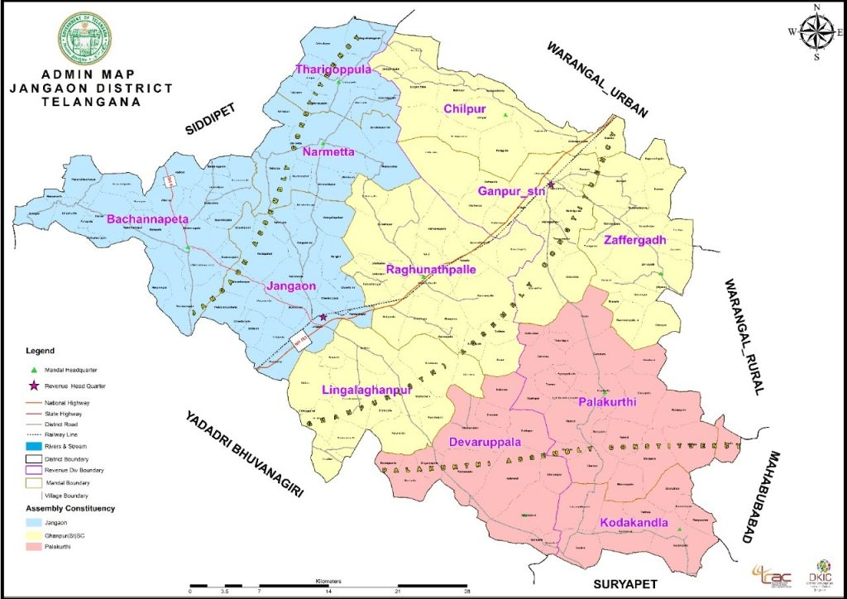

- District Administration :

i) | District Collector | Name | Address | Phone No.
 |  | Smt. K. Nikhila, IAS | Collectorate, Jangaon | 9550798666
ii) | District Coop. Officer | Name | Address | Phone No.
 |  | Sri. M. Maddileti | Dist. Coop. Office, Devadula Quarters, Vadlakonda Road, Jangaon | 9100115739
iii) | District Audit Officer | Name | Address | Phone No.
 |  | Sri. N. Venkateshwar Rao | Dist. Coop. Office, Devadula Quarters, Vadlakonda Road, Jangaon | 8688355023

- Information of Societies in the District :
Sl.No. | TSCS Act, 1964 |  |  | TS MACS Act, 1995
 | Type of Society | No. of Societies | No. of Members | Type of Society | No. of Societies | No. of Members
1 | PACS/FSCS | 14 | 50862 | Credit & Thrift Societies | 468 | 226007

Sd/-
District Cooperative Officer,
Jangaon

